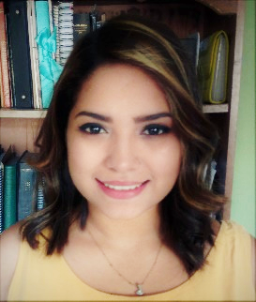

CURRICULUM VITAE

Personal Information
Name: Cecilia Ester Cisneros Padilla
Date and place of birth: October 12, 1996. San Pedro Sula, Cortes, Honduras
Civil status: Single
Identity #: 0512-1996-02354
Nationality: Honduran
Address: Res. Bosques de Jucutuma 3.
Phone: Cel. 3206-7441 or 3215-0662
Email: cecisneros9612@gmail.com

Academic Information:
Elementary School: Aileen Bilingual School
Escuela Experimental San José ¨La Salle¨

High School: Bilingual Institute Dr. Ramon Rosa
Escuela Normal Mixta del Valle de Sula-ENMVS

Obtained Degrees: Primary School Teacher

College: International Trade Career Student at the UNAH

Certificates: Merchant Marine.

Languages:
Spanish
English

Work Experience:

Teacher Aileen Bilingual School Science and Phonics Class Teacher
(first grade-sixth grade)
English Language Tutor
Work from Home

Customer Service Agent Collective Solutions – H2O wireless
Convergys – Cricket Wireless (customer &dealer chat)

Sales Agent Allied Global – Blue Fusion

Expert Sales Associate Oriflame Sweden
2014 - Present

Teacher Villasturias Bilingual Academy

Sales manager Avada Honduras- INMARK

Support Matter Expert Knoah Solutions for Rosetta Stone Language program.

References:

Elliott Nicolás Moran
Cel.3153-7443

Licda. Gladis Berganza
Cel.8764-8038

P.M Claudia Yadira Gómez
Cel.3185-159

